1. 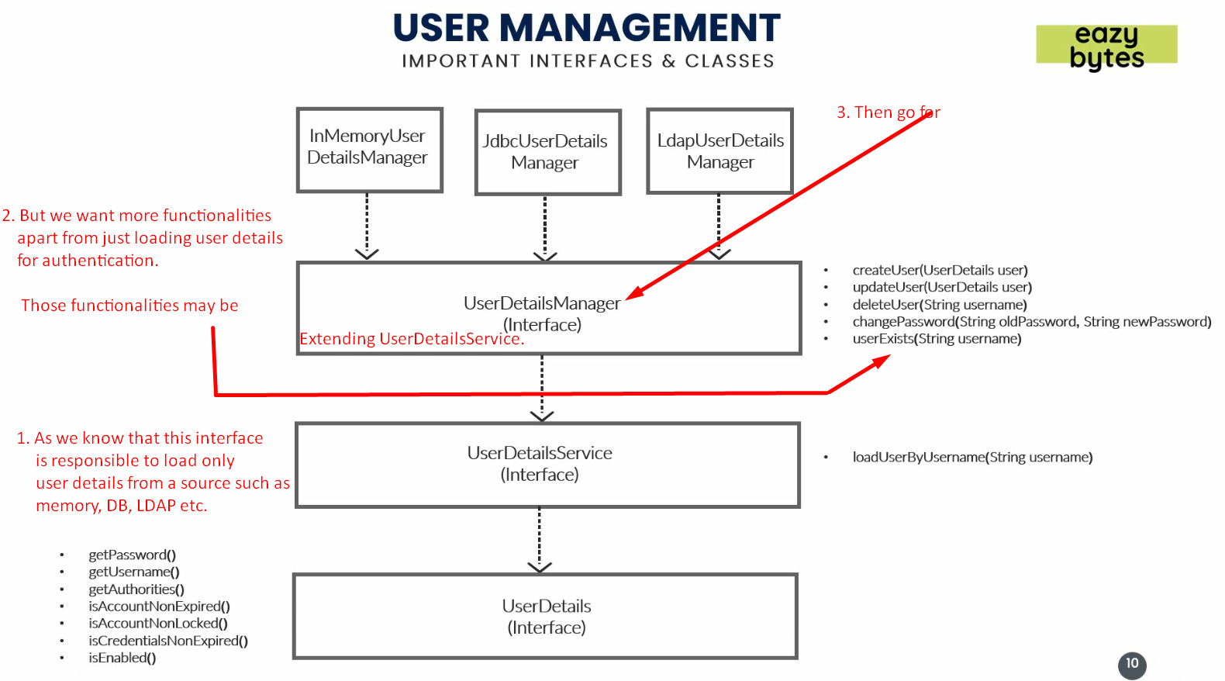
2. Let’s try to see inside the UserDetailsManager interface.
3. 